July 2020 Correlator tests

L band 1K Long track - 1595971406

Example plot for phase ripples in visibilities (blue = data; orange = model)

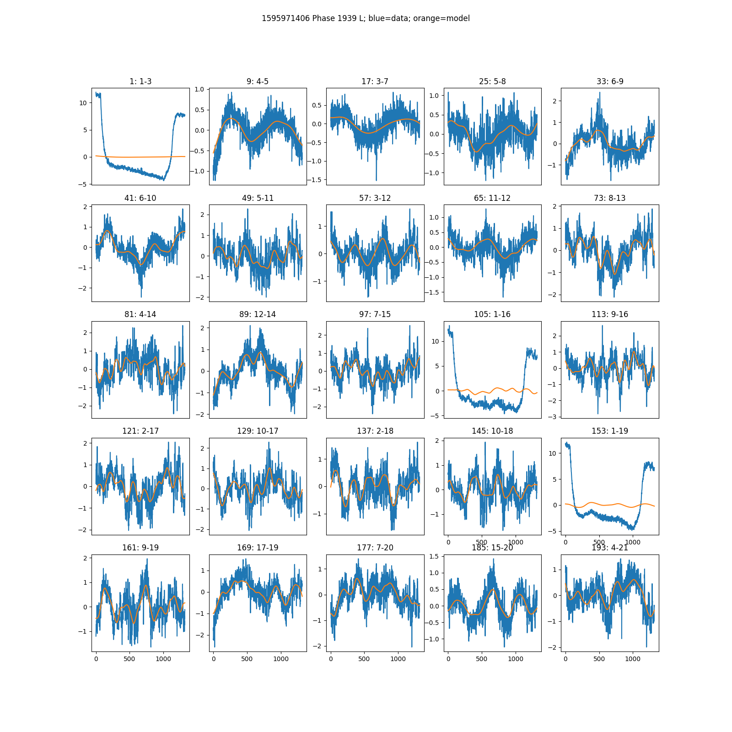

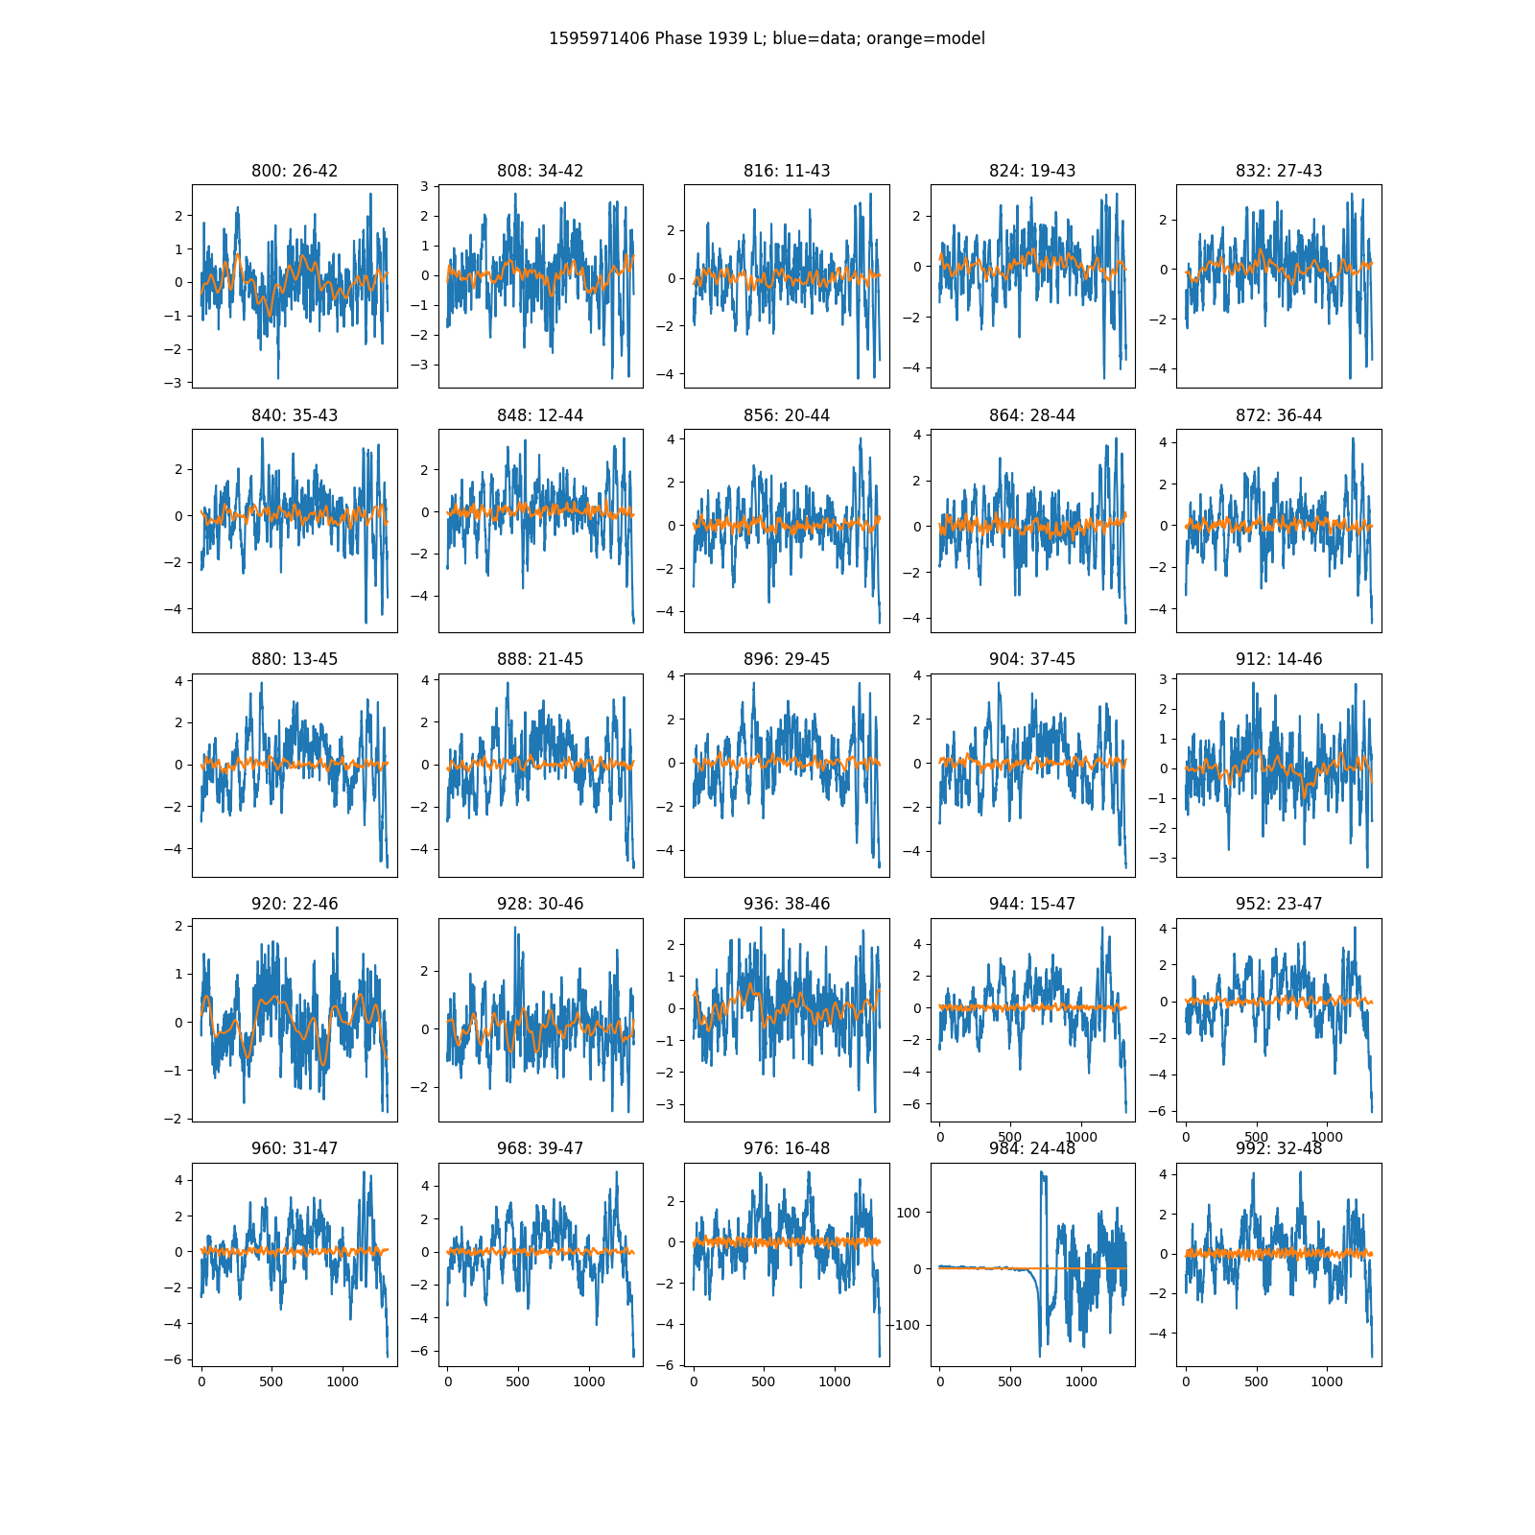

Amplitude of visibilities

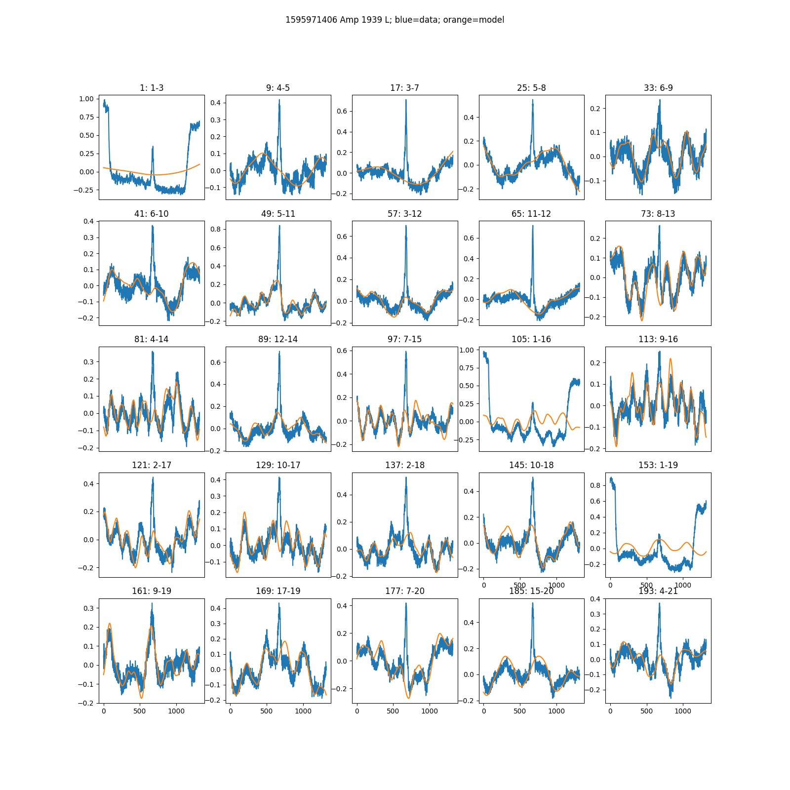

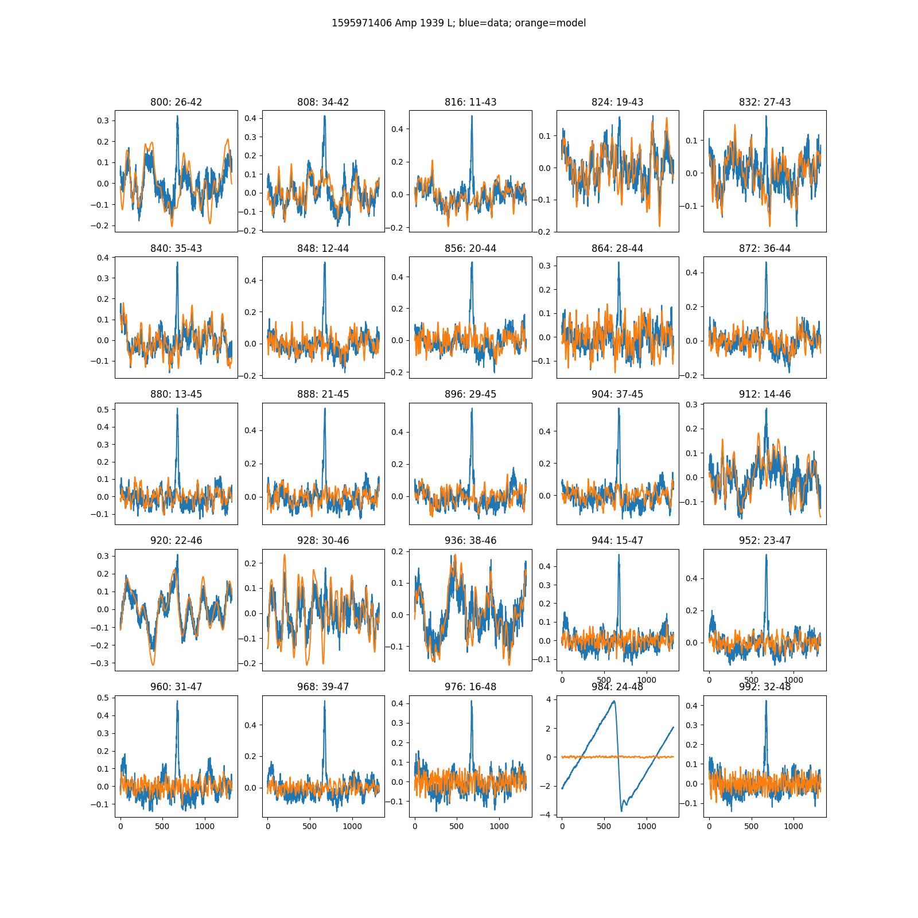

Correlation coefficient of the gain phases of antennas as a function of their baseline length

